____ __________________________
PHONE: (661)947-2884 EMAIL: Palmdalefinandfeatherclub@gmail.com
POST OFFICE BOX 56 ~ PALMDALE, CA 93590
Palmdale Fin & Feather Club
Despite all the chaos of 2020 we had great fishing with more than 23,700 trout and well over 500 catfish caught. 2020 has also brought many of our families closer and lifelong memories made, with the lake being one of the few recreational options for people fortunate enough to belong to our club. As we move through this pandemic it is our goal to keep our members happy and healthy. We are looking forward to holding even more night fishing events and holding our annual Trout Derby, Catfish Derby, and BBQ. In 2021 we will be contracting with Mount Lassen Trout Farm and Superior Catfish to make this another fantastic year of fishing.
We will be accepting applications for 2021 renewals starting Friday, December 11th, 2020. You have until close of business Friday January 29th, 2021 to renew on-time without a late fee. Memberships will be processed in the office only (Please remember your face mask). We are open from 8:00am -5:00pm, do not forget we are closed every Thursday. You can mail in applications, but you are prohibited from fishing opening weekend unless rules and identification cards have been issued beforehand.
**There is a one-time option to place your membership on hold for a $75.00 fee. This is not applicable if your 2020 membership was already placed on hold last year. No hunting or fishing is permitted until all fees are paid in full.
PLEASE VERIFY YOUR MEMBERSHIP TYPE AND SEE BELOW WHAT YOU NEED TO BRING IN ORDER TO RENEW:
- Your filled-out membership renewal application.
- Cash, check, money order, or credit/debit card.
- Palmdale Locals: Bring 2020 Property Tax Bill and Palmdale Water District water bill to verify ownership of property located within the Palmdale Water District.
*Renewal dues for Palmdale Locals are $325.00
- AV Associates: Bring current ID/Driver’s License or utility bill (water, electric or gas) in the member’s name and for the corresponding address listed on the membership.
*Renewal dues for AV Associates are $355.00
- LA Associate: No address verification required.
*Renewal dues for LA Associates are $400.00
Property fees:
Boat Sticker: $50.00
RV Storage: $200.00
Locker: $40.00
Boat Slip: $125.00
Opening Day is Scheduled for Saturday February 6th, 2021.
WE DO NOT ACCEPT CLUB RENEWAL DURING OPENING WEEKEND, EITHER SATURDAY OR SUNDAY. YOU WILL NOT BE PERMITTED TO FISH OPENING WEEKEND UNLESS THIS PROCESS IS PROPERLY HANDLED IN ADVANCE OF OPENING DAY.

*Boat inspection information, board election results & more on back side

BOAT INSPECTION REQUIREMENTS
PLEASE READ OR YOUR BOAT MAY END UP IN IMPOUND
We will continue to impound boats not in compliance with the Fin and Feather Club policy, rules, and regulations. If your boat is in the impound lot, you need to speak to someone in the office. Immediate action must be taken to avoid formal and costly lien sale proceedings. The fee to retrieve your boat from the impound lot, after correction can be up to $10 per day. If your boat is impounded, your membership and all club privileges will automatically be suspended. To ensure your boat is in good standing, please be prepared to show an employee or club volunteer your boat during annual renewal process.
Please understand our rules for boats being stored on our property:
- Your tires cannot be flat. All tires must be inflated.
- Your boat must be towable, and usable at any time.
- Your 2021 Inspection sticker must be correctly placed on your boat in accordance club policy and state law.
- Your member number must be on both sides of the boat, and on tongue of the trailer.
- If your boat is on a trailer you must have a valid 2021 trailer sticker.
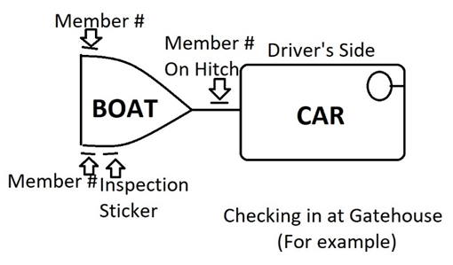
Guide to sticker placement:

Trailer Sticker

All incoming boats (off property without seal or cable) must be inspected a MINIMUM of 14 days before date of use. You must make an appointment for an inspection by calling the office.
Election Results:
President- Joe Beach Director- Richard Salazar
Vice President- Ed Pendergast Director- Steve Derienzo
Recording Secretary – Ed Hall Director- Danny Pham
Membership Secretary – Roger Nicholas Director- Arturo Cuevas
Treasurer – Jim MacCurdy
If you have any questions, do not hesitate to call us at 661-947-2884
Palmdalefinandfeatherclub@gmail.com facebook.com/palmdalefinandfeather

